BIT 4107-Mobile Application Development
ENHANCED PROFESSIONAL STUDENT LOGBOOK
Student name: NICOLE CHEPKEMBOI
Admission Number: BIT/2024/ 54291
School/Faculty: COMPUTING AND INFORMATICS
Program me:
Academic Year: 3
Semester: 2
Lecturer: MICHAEL NYORO
Phone Number:0723402713

WEEK 1: INTRODUCTION TO MOBILE APPLICATION DEVELOPMENT

TOOLS AND SOFTWARE USED
Android Studio
VS Code
Android Mobile phone

PERSONAL REFLECTION
Developing this project using Android Studio and VS Code significantly enhanced my technical skills. Integrating a physical Android mobile phone for testing provided crucial real-world feedback, allowing me to troubleshoot performance issues effectively. This experience deepened my understanding of mobile application development and highlighted the vital importance of real-device testing.

WEEK 2: MOBILE DEVELOPMENT ENVIRONMENT
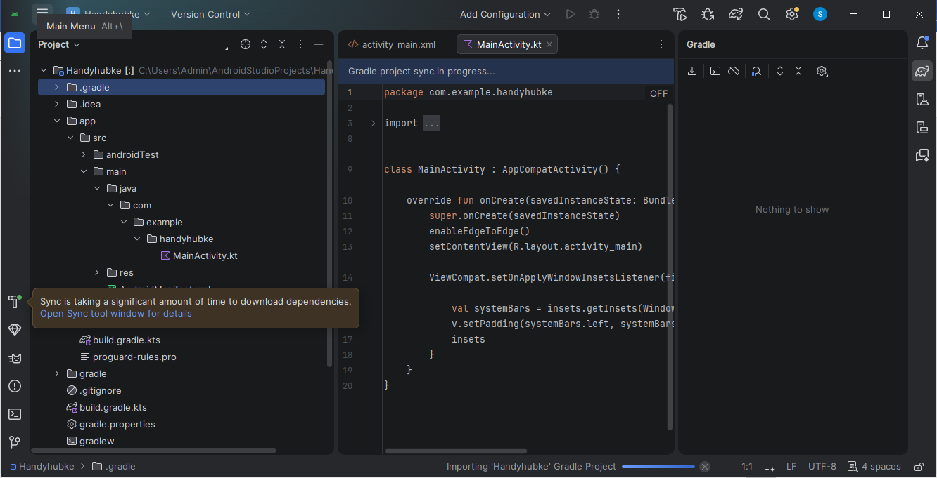
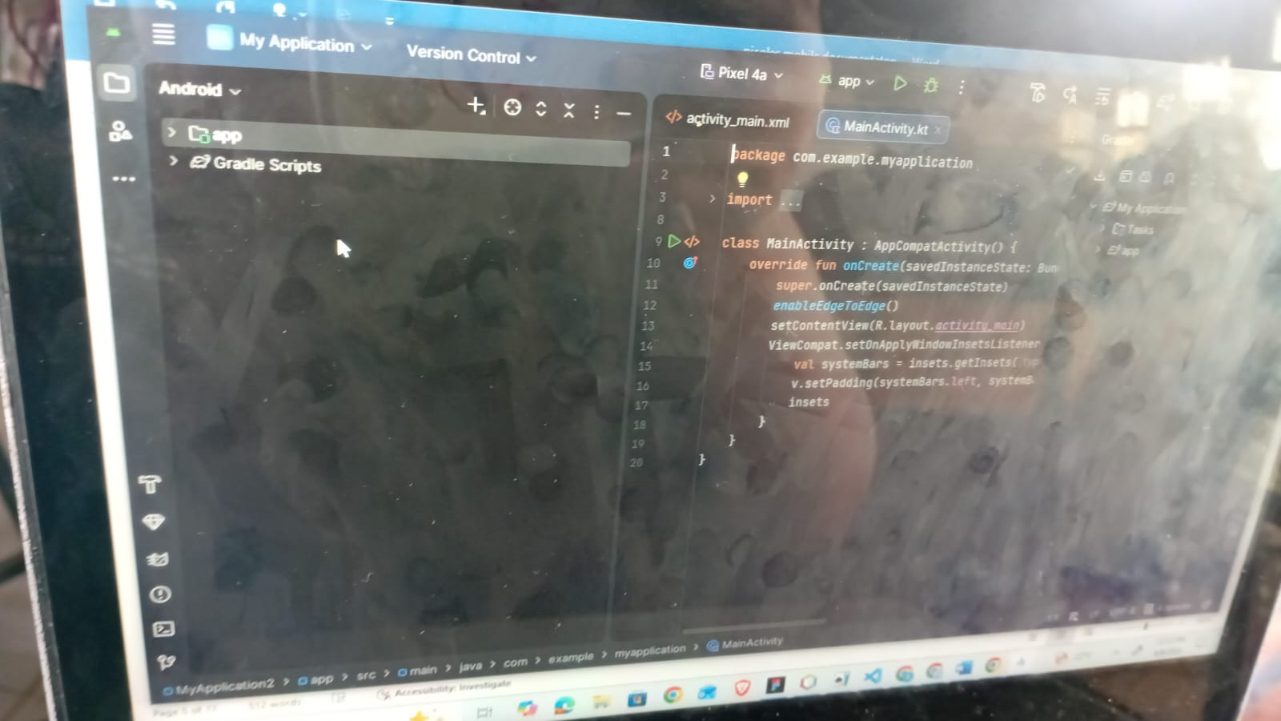
PERSONAL REFLECTIONS
Setting up the Android Studio development environment during week two was a foundational step. Successfully configuring the IDE and syncing Gradle dependencies allowed me to explore the project's file structure and main activity code. This process emphasized the importance of a properly configured environment for efficient development and troubleshooting

WEEK 3: USER INTERFACE DESIGN


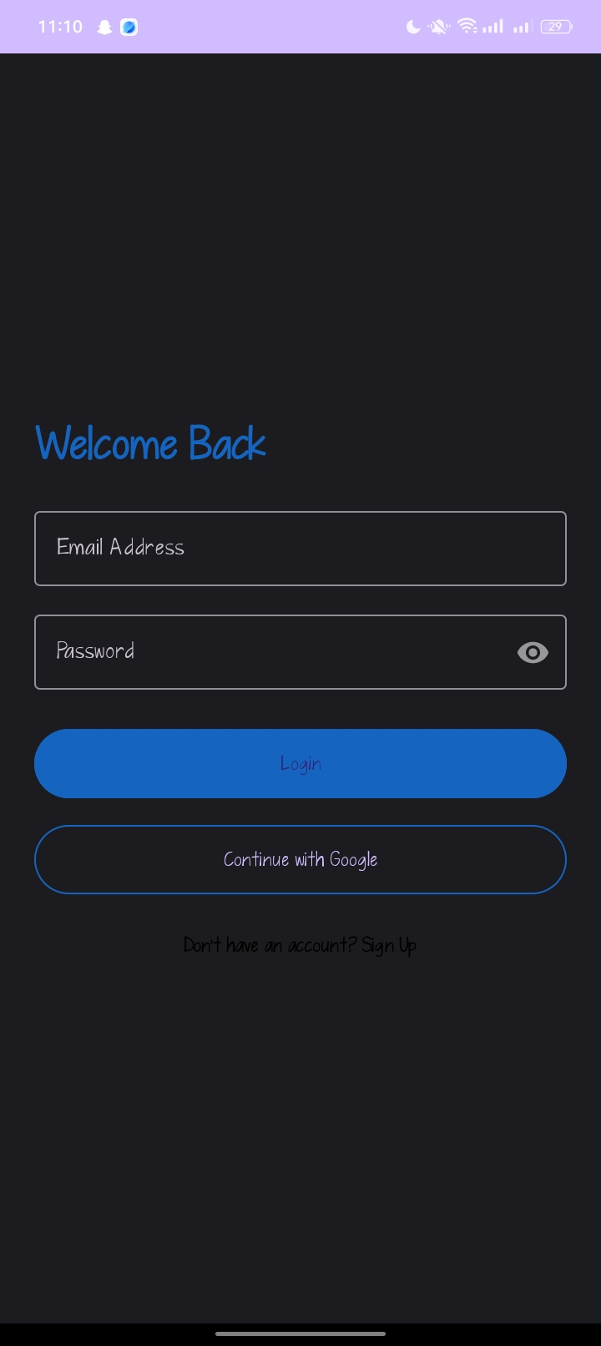

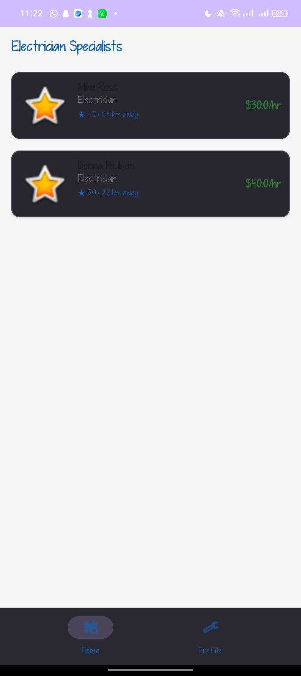
Personal reflection
Designing the HandyHub home screen in week three highlighted the power of User Interface (UI) design. Arranging the search bar, service categories, and featured specialist cards taught me how layout choices directly shape user experience. It was a lesson in balancing clean aesthetics with functional, intuitive navigation.

WEEK 4:EVENT HANDLING AND USER INTERACTION
Personal reflection
This week's focus on event handling and user interaction is vital for HandyHub. Implementing responsive elements—like capturing profile text fields and handling button taps—directly bridges the gap between our users and local service professionals. Seamless interactions ensure intuitive navigation, creating a frictionless, reliable marketplace experience for both homeowners and handyworkers.

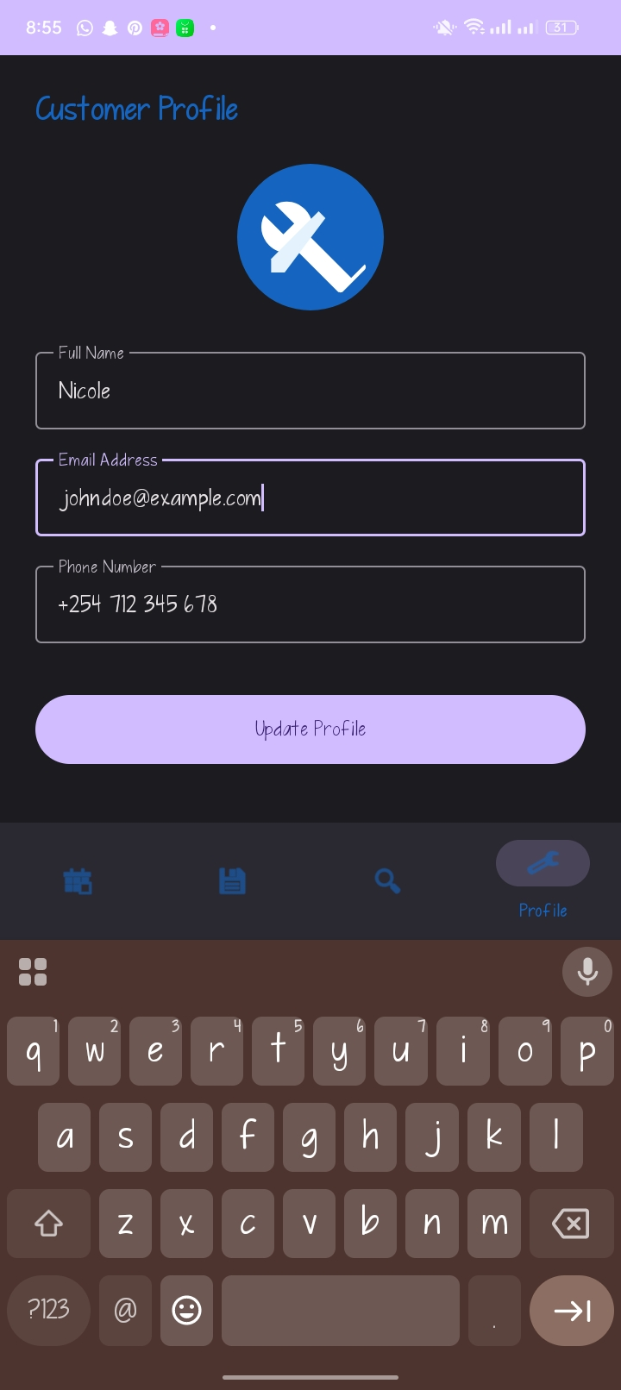
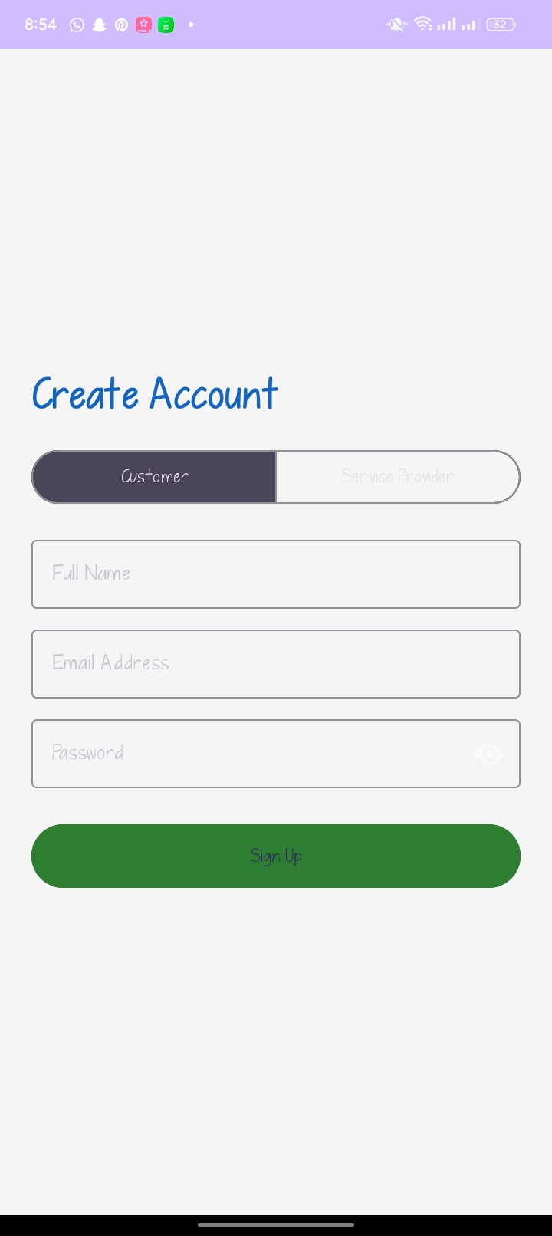
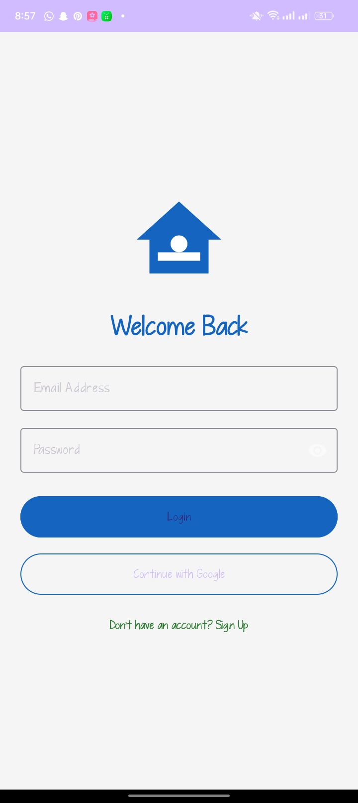.
WEEK 5:DATA MANAGEMENT 
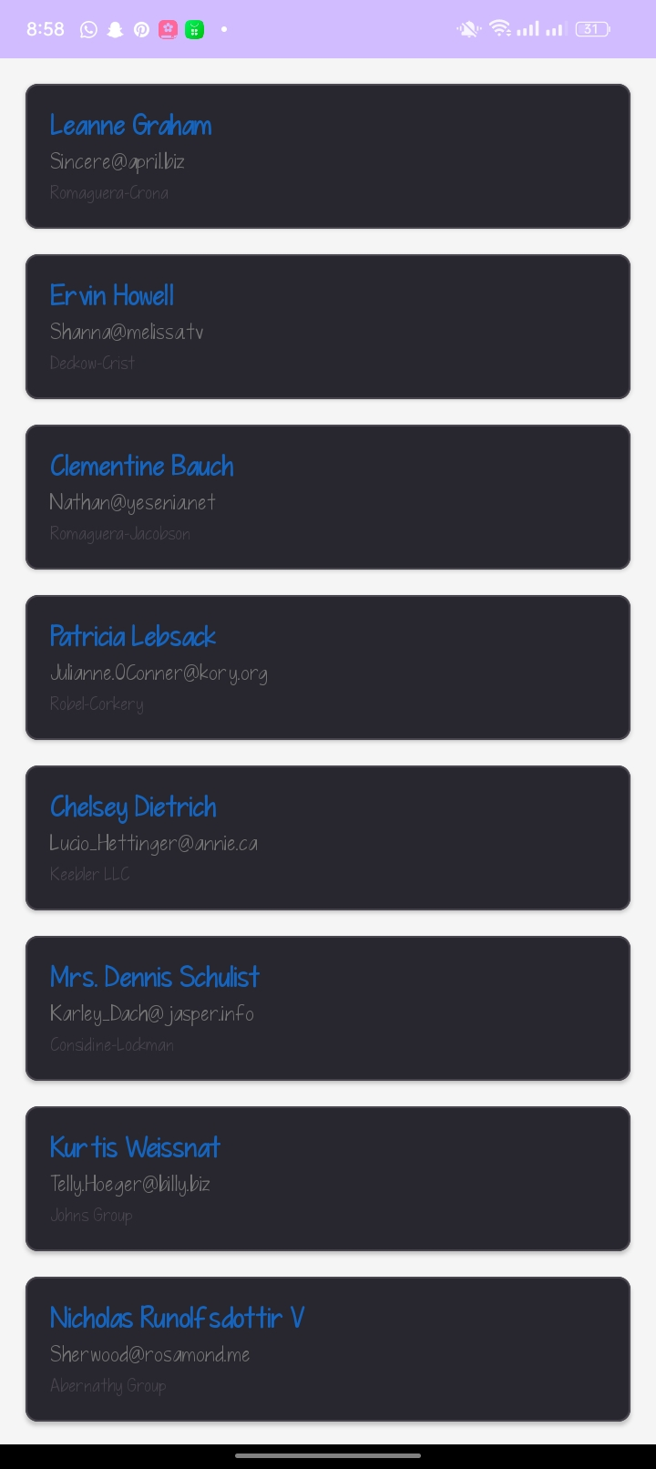
Personal reflection
This week, data management in HandyHub was critical for persistence. Storing and retrieving "Nicole's" specific profile data, like the email and phone number (e.g., +254...), ensures continuity. We've successfully structured the profile database, allowing the "Update Profile" button to save user information reliably, an essential step for user trust.

WEEK 6: NETWORKING AND API’S
NETWORKING CONNECTION STRING
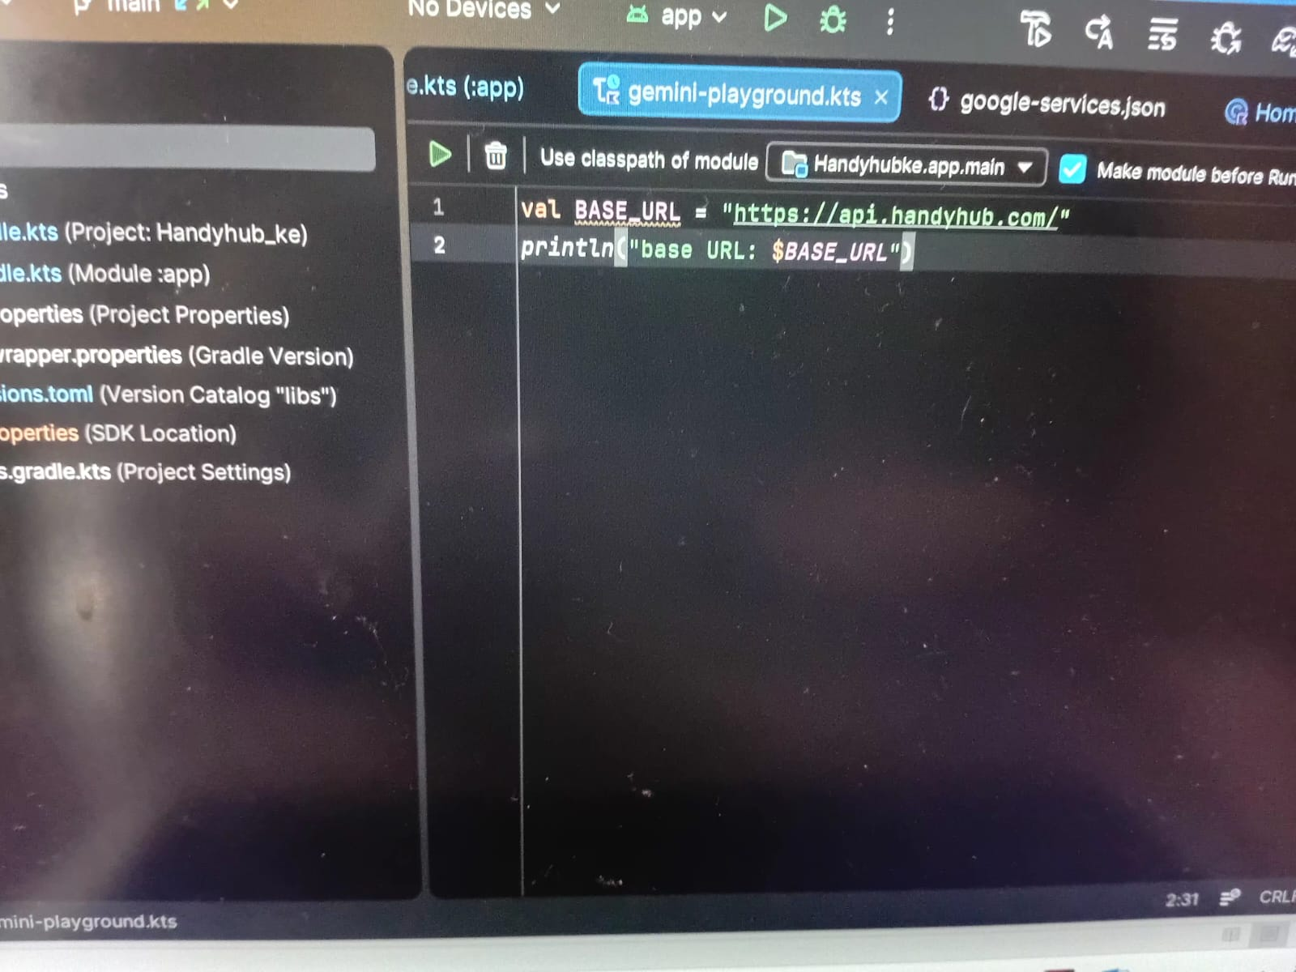

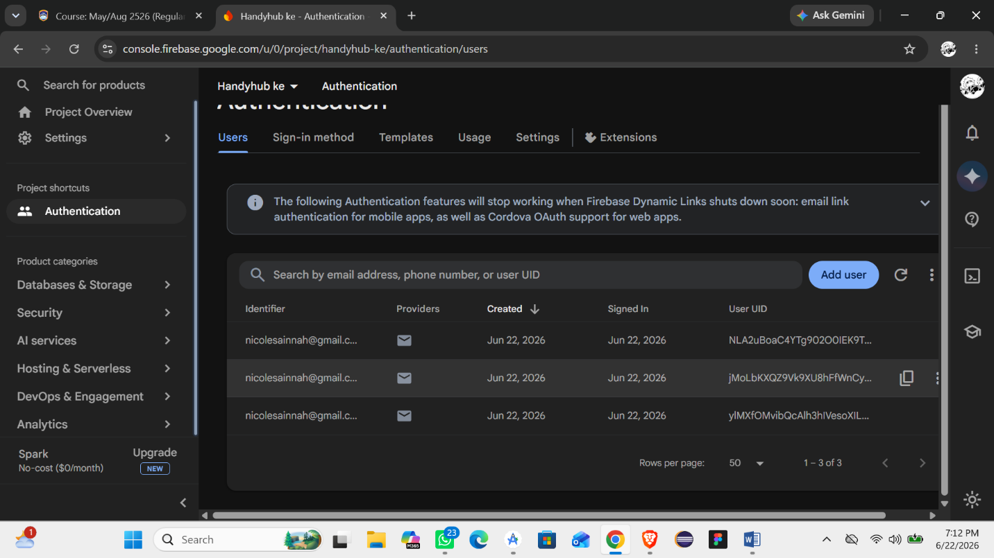
Personal reflection
Networking and APIs highlights a critical step for HandyHub. Integrating Firebase backend infrastructure ensures secure user authentication, reliable data storage, and real-time synchronization. This technical milestone, as shown in file above bridges front-end layouts with functional network APIs to build a robust, scalable marketplace application.
IMPORTANCE OF NETWORKING
Networking connects HandyHub's front-end user interface with Firebase APIs, enabling real-time data sync, secure user authentication, and seamless service bookings.

WEEK 7 :DATA STORAGE AND DATABASE INTERGRATION IN MOBILE APLLICATIONS
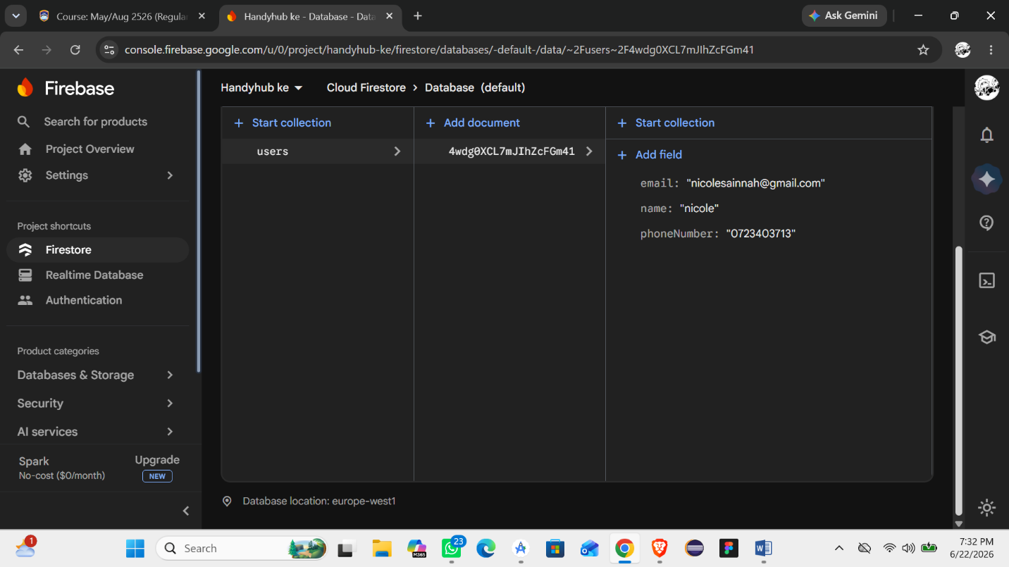


Personal reflection
Integrating Firebase into Handy Hub during Week 7 was a definitive turning point. Successfully configuring Cloud Firestore transformed a static UI into a functional mobile application with persistent, real-time user data. Witnessing successful data integration validated my backend development skills and bridged the gap between raw code and actual user utility.

